TITLE: POSTER CREATION

USER NAME: 67F6CF7AEAE3B5CBCBC43CBB46746FBB

1.Open canva App

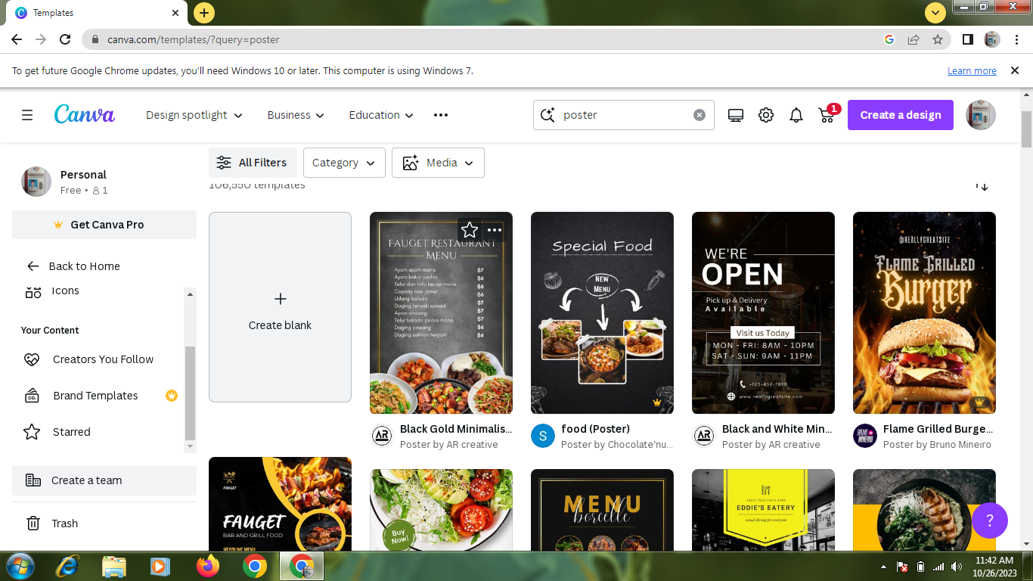

2. select a template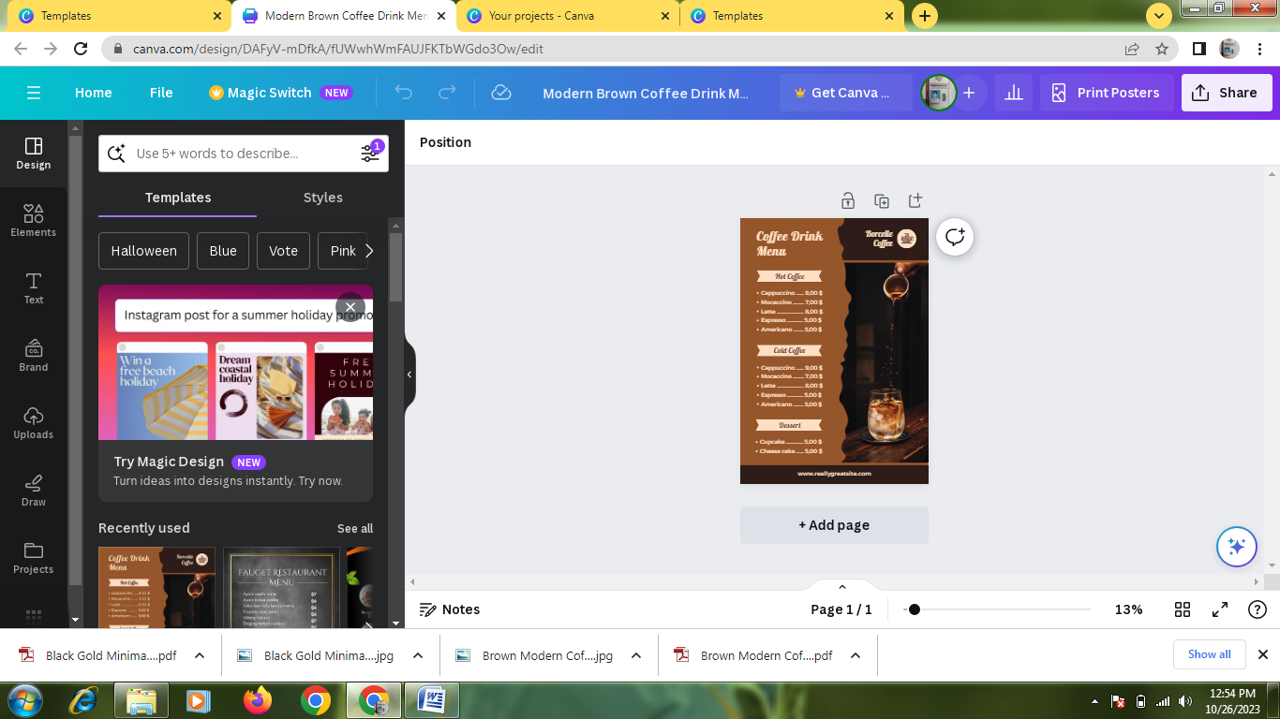

3.Edit a details

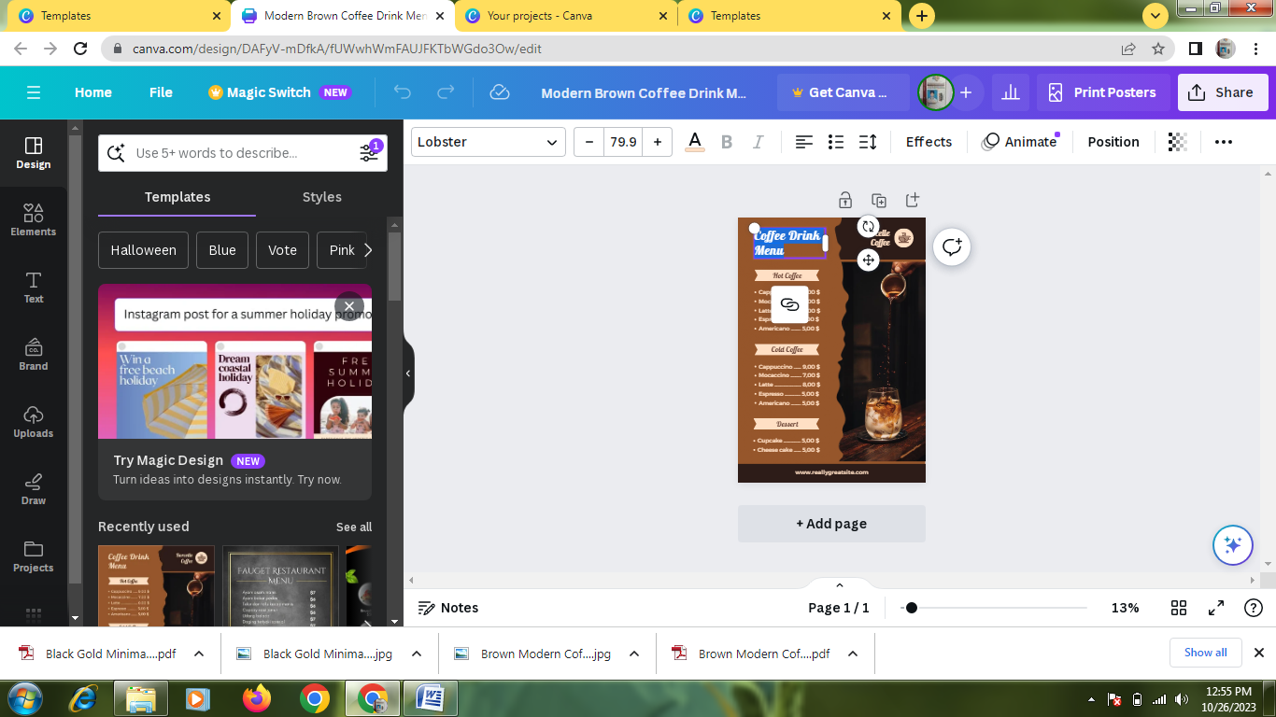

4.Upload a business related image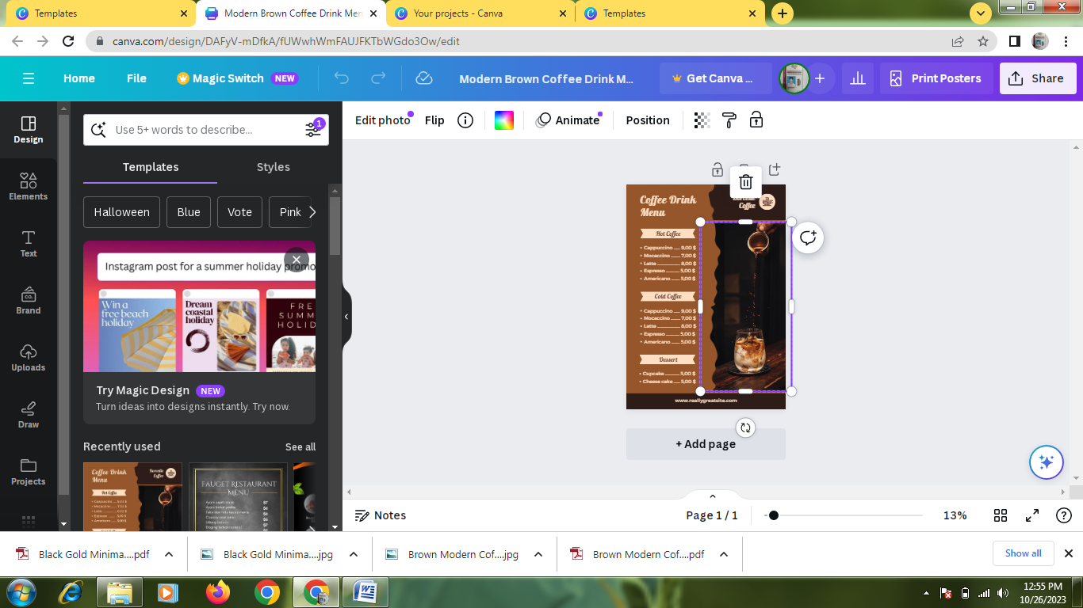

5.Pdf convert

